
JURONG JUNIOR COLLEGE
PRELIMINARY EXAMINATION 2008

H2 CHEMISTRY PAPER 2

9746 / 2
Friday | 22nd August 2008 | 1 hour 30 minutes

Name: ______________________ ( No. ________) Class: 07_____

INSTRUCTIONS TO CANDIDATES
Do not open this booklet until you are told to do so.

Write your name, exam index number and class in the spaces at the top of this page.
Write in dark blue or black pen in the spaces provided on the Question Paper.
You may use a pencil for any diagrams, graphs, or rough working.
Do not use highlighters or correction fluid.

Answer all questions.

INFORMATION FOR CANDIDATES

A Data Booklet is provided. Do not write anything on the Data Booklet.

The number of marks is given in brackets [ ] at the end of each question or part question.
You are advised to show all workings in calculations.
You may use a calculator.

 |  | FOR EXAMINER’S USE
 |  | 1
 |  | 2
 |  | 3
 |  | 4
 |  | 5
 |  | 6
 |  | TOTAL |  | / 60
This question paper consists of 13 printed pages, including this page.

[Turn over
1. | Many copper minerals are found in hydrothermal deposits where they were formed by crystallisation from very hot solutions. Deep underground, it is like a giant pressure cooker and water is still in liquid form at high temperature. This means that minerals which are regarded as ‘insoluble’ in the laboratory can dissolve under these conditions. When the solutions cool, the minerals crystallise out.  One such copper mineral is chalcopyrite, CuFeS₂, which is a copper iron sulfide mineral that crystallises out in a tetragonal system. Chalcopyrite is one of the minerals referred to as ‘Fool's Gold’ due to its brassy yellow appearance.
 | (a) | Chalcopyrite can be smelted in modern works by heating with air.  3CuFeS₂ + 8O₂ 3Cu + FeO + Fe₂O₃ + 6SO₂  A rock sample was found to contain 0.5 % by mass of chalcopyrite.
 |  | (i) |  | Calculate the volume of sulfur dioxide gas released into the atmosphere at r.t.p. if 1 tonne of the rock sample is smelted. (1 tonne = 1000 kg)  Mass of CuFeS₂ smelted = 5000 g  Amount of CuFeS₂ smelted = 27.2 mol  3CuFeS₂ ≡ 6SO₂  Vol. of SO₂ evolved = (2 × 27.2) × 24  = 54.4 × 24 = 1310 dm³
 |  | (ii) |  | Suggest a reason why we should try to limit the emission of sulfur dioxide into the atmosphere.  To prevent the formation of acid rain, which will corrode buildings and endanger aquatic life.  ………………………………………………………………………………  ……………………………………………………………………………… | [4]
1. | Chalcanthite, known as ‘copper flower’, is a water soluble copper sulfate mineral. When dissolved, aqueous copper(II) sulfate contains [Cu(H₂O)₆]²⁺ ions.
 | (b) |  | Water is a simple molecule. The H−O−H bond angle in an isolated water molecule is 104.5 °.  The diagram below shows part of the [Cu(H₂O)₆]²⁺ ion and the H−O−H bond angle in the water ligand.  H  107 °  Cu²⁺ O  H
 |  |  | (i)  Both oxygen atoms have tetrahedral arrangement of its four electron pairs.  The oxygen atom in isolated water molecule has 2 bond pairs and 2 lone pairs, thus it has a bent shape with bond angle 104.5 °.  When water is a ligand, the oxygen atom has 3 bond pairs and 1 lone pair, thus it has a trigonal pyramidal shape with bond angle 107°.  This is because lone pair-lone pair repulsion is greater than bond pair-lone pair repulsion which is greater than bond pair-bond pair repulsion. | Explain why the H–O–H bond angle in the water ligand is 107 ° while that in an isolated water molecule is 104.5 °.  ………………………………………………………………………………  ………………………………………………………………………………  ………………………………………………………………………………  ………………………………………………………………………………  ………………………………………………………………………………  ………………………………………………………………………………  ………………………………………………………………………………  ………………………………………………………………………………
 |  |  | (ii) | State the hybridisation state of the oxygen atom in the water ligand.  ………………………………………………………………………………  sp³ | [5]
 | (c) | Describe and explain the observations made when aqueous ammonia is added slowly to a small volume of aqueous copper(II) sulfate solution, until in excess.  Identify all of the copper-containing species formed.  When NH₃(aq) is added, a pale blue ppt of Cu(OH)₂(s) is formed, which dissolves in excess NH₃(aq) to form a deep/dark blue solution, of Cu(NH₃)₄(H₂O)₂²⁺ (aq).  The stronger NH₃ ligand displaces the weaker H₂O ligand as NH₃ forms a stronger dative (covalent) bond with Cu²⁺ to form a more stable Cu(NH₃)₄(H₂O)₂²⁺ (aq) complex.  ……………………………………………………………………………………..  ……………………………………………………………………………………..  ……………………………………………………………………………………..  ……………………………………………………………………………………..  ……………………………………………………………………………………..  …………………………………………………………………………………….. |  |  | [3]
 |  | [Total: 12]

2. | (a) | The graph below is an Ellingham diagram, which shows the variation in the standard free energy change of formation, ∆G_{f}, with temperature, T, for both carbon monoxide and zinc oxide.  ∆G_{f}/kJ mol⁻¹  0 500 1000 1500 2000 2500 3000  T / K  2C + O₂ 2CO  2Zn + O₂ 2ZnO  0  −200  −400  −600  −800  Boiling point of Zn  Melting point of Zn
 |  | (i) | By considering the relationship between the free energy change, ∆G, the enthalpy change, ∆H, and the entropy change ∆S for a reaction, suggest how you would obtain a value for entropy change from the Ellingham diagram above.  Since ∆G= ∆H - T∆S, ∆S is the negative of the gradient of the graph.  …………………………………………………………………………….  …………………………………………………………………………….
 |  | (ii) | Explain why the line for carbon monoxide in the diagram above has a negative gradient.  There is an increase in entropy since the amount of gaseous molecules increased from 1 to 2 mol.  …………………………………………………………………………….  …………………………………………………………………………….
 |  | (iii) | Deduce, from the diagram, which oxide, CO or ZnO, is the stronger oxidising agent at 1800 K.  ZnO is the stronger oxidising agent.  ……………………………………………………………………………. | [3]
 | (b) | Explain why carbon monoxide is toxic, with reference to its interactions with haemoglobin, an important iron−containing complex in red-blood cells that transports oxygen around the body.  ……………………………………………………………………………………  Being a much stronger ligand than O₂, CO ligand forms a stronger dative bond with the Fe(II) ion, hence displacing O₂ from the complex. This results in the inability of haemoglobin to transport oxygen to the cells and thus CO acts as a poison.  …………………………………………………………………………………… |  | [1]

2. | (c) | In heavily polluted air, nitrogen dioxide is often formed and it appears as a brown haze with a sharp biting odour.  Besides causing human respiratory problems and other adverse health effects, nitrogen dioxide also plays a part in destroying the ozone layer through a free radical chain mechanism, similar to that caused by the harmful chlorofluorocarbons (CFCs).
Nitrogen dioxide gas is formed by the following reaction between nitrogen oxide and oxygen gas.
2NO(g) + O₂(g) ( 2NO2(g) ΔH = –57 kJ mol(1
The following mechanism has been proposed for the reaction:
Step 1: NO + O2 ( NO3 (fast)
Step 2: NO3 + NO ( 2NO2 (slow)
 |  | (i) | Draw a dot-and-cross diagram to show the arrangement of the valence electrons in NO₂.  .. × ..  :O N :O:  ×  ×  ×  ×  ..
 |  | (ii)  Rate = k’[NO₃][NO] = k’( K_{c}[NO][O₂] )[NO] = k [NO]² [O₂] | Based on the proposed kinetics, deduce the rate equation for the reaction.  ……………………………………………………………………………..
 |  | (iii)  Energy  Reaction Profile  2NO + O₂  2NO₂  NO₃ + NO | Sketch an energy profile diagram for the proposed mechanism in the space below. Label your diagram clearly, including the reactants and the products formed. | [4]
 |  |  | [Total: 8]

3. | A cell set-up based on the magnesium-iodine system consists of a magnesium electrode dipped in magnesium nitrate electrolyte and a platinum electrode dipped in aqueous iodine-sodium iodide electrolyte.
 | (a) | (i) | Draw a diagram to illustrate the set up of the cell, showing the direction of the electron flow in the external circuit.
1 mol dm⁻³ I₂(aq),
1 mol dm⁻³ I⁻(aq), 25ºC

e⁻ (flow)
V
Pt (s)
salt bridge
Mg(s)
(─)
(+)
1 mol dm⁻³ Mg²⁺(aq),
25ºC

 |  | (ii) | Write a balanced equation for the cell reaction.
 |  |  | Overall eqn: Mg(s) + I₂ (aq) 2I⁻(aq) + Mg²⁺(aq)
 |  | (iii) | Calculate the cell e.m.f. under standard conditions.
Eo _{cell} = Eo(I₂/I─) − Eo(Mg²⁺/Mg) = +0.54 – (– 2.38)
= +2.92 V
 |  | (iv) | How would you expect the e.m.f. of this cell to change, if at all, when the concentration of magnesium ions is doubled? Explain your answer.  Mg²⁺ + 2e⁻ Mg Eo = −2.38 V (*)  Equilibrium position of (*) shifts to the right. As a result, E(Mg²⁺/Mg) becomes more positive. Hence the cell potential becomes less positive.  ……………………………………………………………………………..  ……………………………………………………………………………..  ……………………………………………………………………………..  …………………………………………………………………………….. | [7]
3. | (b) | Sodium iodide occurs as colourless crystals or as white crystalline powder. The primary use for sodium iodide is in the treatment of actinobacillosis in cattle, where aqueous sodium iodide solution is injected intravenously into the animals.
 |  | (i)  Energy/ kJ mol⁻¹ | Draw an energy cycle on the grid below, using the following data, to determine the enthalpy change of solution, ∆H_{soln}, for NaI.  Enthalpy change of lattice energy of NaI –704 kJ mol⁻¹  Enthalpy change of hydration energy of Na⁺(g) –390 kJ mol⁻¹  Enthalpy change of hydration energy of I⁻(g) –247 kJ mol⁻¹  Na⁺ (g) + I⁻ (g)  Na⁺ (aq) + I⁻ (aq)  ∆H^{θ}_{hyd}(Na⁺)  + ∆H^{θ}_{hyd}(I⁻)  NaI (s)  ∆H^{θ}_{soln}(NaI(s))  LE (NaI)  By Hess' Law, ∆H^{θ}_{soln}(NaI(s)) = ΔH0hyd(Na+) + ΔH0hyd(I─) − ΔH0_{LE}(NaI(s))  = (−390) + (−247) − (− 704)  = +67 kJ mol⁻¹
 |  | (ii) | The enthalpy change of hydration of Cl⁻ is −362 kJ mol⁻¹. Explain why this is more exothermic than that of I⁻.  Ionic radius of Cl⁻ is smaller than that of I⁻. Charge density of Cl⁻ is  greater than that of I⁻.Cl⁻ forms stronger ion-dipole interactions  with water molecules than I⁻.  ……………………………………………………………………………..  ……………………………………………………………………………..  ……………………………………………………………………………..
 |  | (iii) | Astatine is the element below iodine in Group VII.  Identify the halogen-containing substances when concentrated sulfuric acid is added to a solid mixture of sodium chloride and sodium astatide. Write equations for the reactions that occur.
HCl, HAt, At₂
NaCl(s) + H₂SO₄(l) → HCl(g) + NaHSO₄ (s)
NaAt(s) + H₂SO₄(l) → HAt(g) + NaHSO₄ (s)
8HAt(g) + H₂SO₄(l) → 4At₂(g) + H₂S(g) + 4H₂O(l)

 |  |  |  | [7]
 |  |  | [Total: 14]

4. | The reaction scheme below involves adrenalin, a hormone and neurotransmitter.  B
E
D
4. | (a) | (i) | Suggest the structural formula of compound B and draw it in the box provided.
 |  | (ii) | Suggest reagents and conditions required in steps I and II.  HCN, trace amount of NaCN  Step I : ………..………………………………………………………  LiAlH₄, dry ether  Step II : ………..………………………………………………………
 |  | (iii) | Draw the structural formula of the organic products D and E in the boxes provided. | [5]
 | (b) | Suggest a simple chemical test that can be used to distinguish between adrenalin and the following compound :  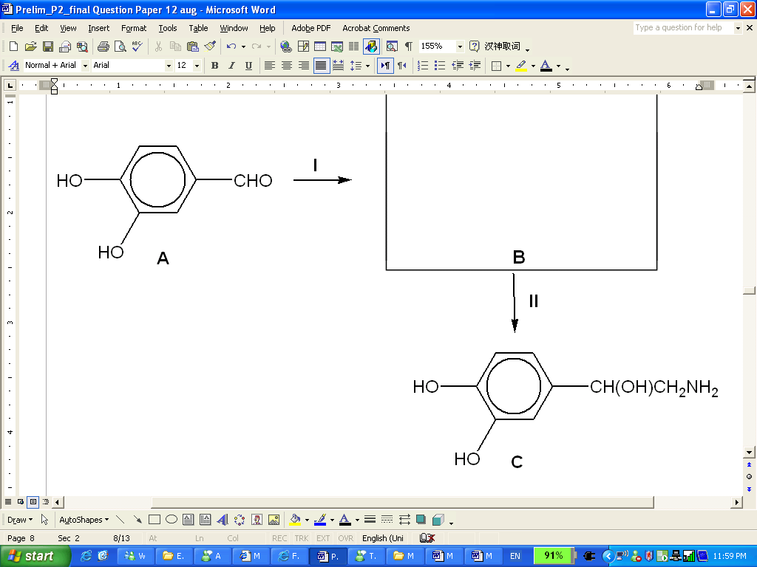  ONHCH₂CH₃  Test: Add PCl₅ to both compounds separately.  Observations:  For Adrenalin, white fumes will be observed.  For the compound, no white fumes will be observed. |  | [2]
 |  | [Total: 7]

5. | Compounds R, S and T are shown below.
 | (a) | Arrange the compounds in order of increasing ease of hydrolysis. Explain your answer.  In order of increasing ease of hydrolysis: T < S < R  T is least susceptible to hydrolysis as the lone pair of electrons on Cl is delocalised into the benzene ring thus making the C-Cl bond very strong and hence more difficult to break.  R is more susceptible to hydrolysis than S as the carbon of the COCl group is highly electron deficient as it is bonded to 2 electronegative atoms. Thus the carbon is more susceptible to nucleophilic attack. |  | [3]
 | (b) | Describe an experiment to determine the relative ease of hydrolysis of the compounds R, S and T.  - Add AgNO₃(aq) to equal volumes of R, S and T in separate test tubes  - At the same time, start the stop watch and record the time taken for ppt to appear in each of the test tubes.  - The shorter the time taken. The faster the rate of hydrolysis. |  | [2]
5. | (c) | Compound S can be made by the free-radical chlorination of cyclohexane. Describe the reaction mechanism of its formation.
 |  | Initiation step:  Cl₂ 2Cl  Propagation step:  + Cl + HCl  + Cl₂ + Cl  Termination step:  +  2Cl Cl₂  + Cl  uv |  | [3]
 |  |  | [Total: 8]

6. | There are four levels of organisation found in the structure of a protein. The primary structure of a protein determines its secondary, tertiary and quaternary structures.  The formulae of three amino acids are given.  asparagine (asn) alanine (ala) glutamic acid (glu)
 | (a) | Draw the structural formula of a portion of a protein with the sequence asn-ala-glu in its primary structure, showing the form in which it would exist at pH 12.
 |  |  |  | [2]
 | (b) | The two main secondary structures are the α−helix and β−pleated sheet.  Describe what β−pleated sheets are. Illustrate your description with a diagram to show how two strands in a protein can be involved in maintaining the β−pleated structure, clearly indicating and labelling any bonds established between the strands.  β-pleated sheet consists of adjacent polypeptide strands stabilised by hydrogen bonds between the backbone C=O group of one strand and the backbone N-H group of the adjacent strand.  C  O  H  N  adjacent strand  C  O  H  N  hydrogen bonds or hydrogen bonding  One strand of polypeptide chain  ……………………………………………………………………………………..  ……………………………………………………………………………………..  ……………………………………………………………………………………..  …………………………………………………………………………………….. |  | [3]
6. | (c) | The overall three-dimensional shape of a protein is stabilised by interactions between the side chains of the amino acid residues.  State the type of side-chain interactions that are possible for each of the amino acids, asparagine and glutamic acid at pH 12.  Asparagine : Hydrogen bond  Glutamic acid : Ionic bond  ……………………………………………………………………………………..  …………………………………………………………………………………….. |  | [2]
 | (d) | Alanine is a naturally occurring amino acid that is found primarily in poultry, beef, pork and fish.  Draw the structure of the products formed when alanine is reacted with:
 |  | (i) | hot propan-2-ol in the presence of concentrated sulfuric acid
 |  | (ii) | ethanoyl chloride | [2]
 | (e) | Alanine can also react with CH₃Cl in a 1:1 mole ratio. State the type of reaction involved and give the structure of the organic product.  Nucleophilic Substitution |  | [2]
 |  |  | [Total: 11]

